Directions: Sketch the graphs of the following equations.

$y=3x−4$ $y=−2x+5$ $y=\frac{1}{3}x−1$

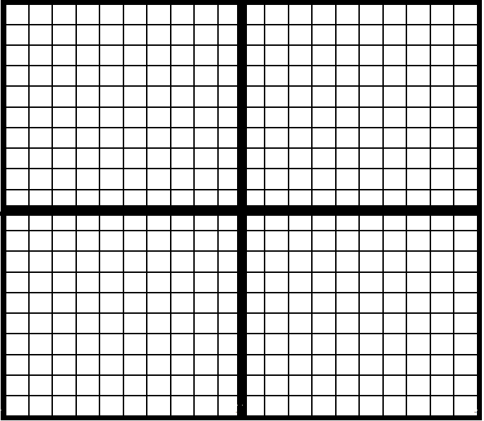

$y=−\frac{3}{2}x+2$ $y=\frac{4}{3}x+1$ $y+2x=3$

$2y−x=4$ $4x+2y=−2$ $3y−2x=−6$

